PRACTICAL 8

* Create a 3Dbar for a smaple data

import matplotlib.pyplot as plt fig=plt.figure (facecolor='k') axl=fig.add_subplot (111,projection='3d') xpos=[10,20,30,40,50] ypos=[100,200,300,400,500] zpos=[0,0,0,0,0] dx=[10,10,10,10,10] dy=[100,100,100,100,100] dz=[1,2,3,4,5] axl.bar3d(xpos,ypos,zpos,dx,dy,dz,color="blue") axl.set_facecolor("pink") plt.show() Output :

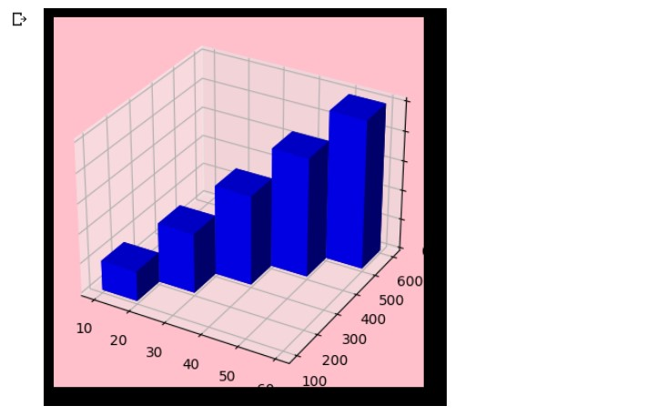

PRACTICAL 9

* Demonstrate some matpotlib animations

import matplotlib.pyplot as plt import pandas as pd

from matplotlib.animation import FuncAnimation data = pd.read_csv("C:/Users/Student/Desktop/file1.csv") xdata,ydata=[],[] fig,ax=plt.subplots() ln, = plt.plot([],[],'r')

ax.set_xlim(data['x'].min(),data['x'].max()) ax.set_ylim(data['y'].min(),data['y'].max()) def init(): ln.set_data([],[]) return ln, def update(frame):

xdata.append(data['x'][frame]) ydata.append(data['y'][frame])

ax.fill_between(xdata,y1=0,y2=ydata,color='b',alpha=0.3) ln.set_data(xdata,ydata) return ln,

ani = FuncAnimation(fig,update,frames=range(len(data)),init_func=init,

interval=100,blit=True) ani.save("C:/Animation/Ani1.gif",writer="pillow") plt.show() Output :

